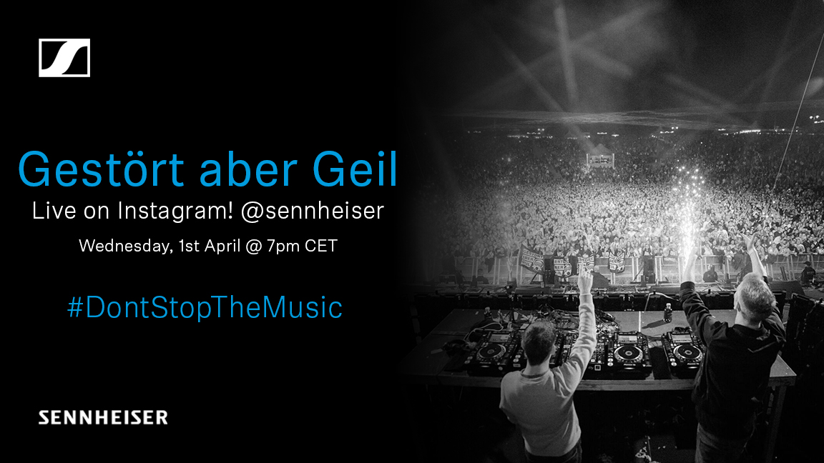 | 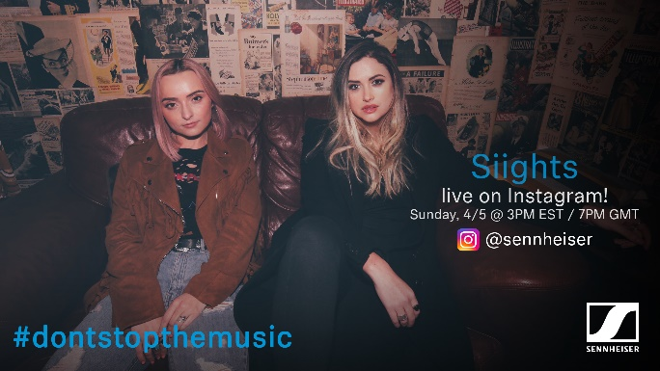

#DontStopTheMusic

International artists continue to entertain stay-at-home audiences with live Instagram gigs

Sydney/Wedemark, April 1, 2020 – Sennheiser’s #DontStopTheMusic series is set to see even more artists from around the globe delivering exciting live performances to your home. “We would like to thank all the amazing artists for joining #DontStopTheMusic and playing to their fans – and reaching out to new audiences too – via our @sennheiser Instagram channel,” said Pierre Morant, Head of Relationship Management with Sennheiser. “A special thank-you goes out to the crews who support them, their engineers, management, and social media teams – we are enjoying working with you so much!”

Live concert streams from Wednesday, April 1 to Tuesday, April 7
Within the next seven days, Jenny from O’Sisters, Gestört aber geil, Idriss D, Saves the Day (Chris Conley), Kungs, Oso Oso, Delanila, Dogleg, Siights, Bradley Walden, DJ Cutkiller, Willie J. Healey, and Sublime with Rome will all broadcast their performances live via IGTV. Please follow @sennheiser on Instagram and don’t forget to switch on notifications in IGTV to receive alerts, as dates and artists may be subject to change at short notice.

- Jenny from O’Sisters (@o.sisters)
Wednesday, April 1 at 16:00 UTC (Thursday, April 2 at 3:00 a.m. AEDT)
- Gestört aber geil (@gestoert_aber_geil_official):
Wednesday, April 1 at 15:00 UTC (Thursday, April 2 at 2:00 a.m. AEDT)
- Idriss D (@idrissdoff):
Thursday, April 2 at 15:00 UTC (Friday, April 3 at 2:00 a.m. AEDT)
- Saves the Day (Chris Conley) (@savestheday):
Thursday, April 2 at 20:00 UTC (Friday, April 3 at 7:00 a.m. AEDT)
- Kungs (@kungs):
Friday, April 3, 16:00 UTC (Saturday, April 4 at 3:00 a.m. AEDT)
- Oso Oso (@osoosoband):
Friday, April 3 at 19:00 UTC (Saturday, April 4 at 6:00 a.m. AEDT)
- Delanila (@delanila):
Saturday, April 4 at 19:00 UTC (Sunday, April 5 at 5:00 a.m. AEST)
- Dogleg (@doglegband):
Saturday, April 4 at 20:00 UTC (Sunday, April 5 at 6:00 a.m. AEST)
- Siights (@siights)
Sunday, April 5 at 19:00 UTC (Monday, April 6 at 5:00 a.m. AEST)
- Bradley Walden (of Emarosa) (@bradley.waldon):
Sunday, April 5 at 21:00 UTC (Monday, April 6 at 7:00 a.m. AEST)
- DJ Cutkiller (@djcutkiller)
Monday, April 6 at 16:00 UTC (Tuesday, April 7 at 2:00 a.m. AEST)
- Willie J. Healey (@williejhealey):
Monday, April 6 at 19:00 UTC (Tuesday, April 7 at 5:00 a.m. AEST)
- Sublime with Rome (@sublime)
Tuesday, April 7 at 20:00 UTC (Wednesday, April 8 at 6:00 a.m. AEST)

* A note on the time zones
The concert times are given in Coordinated Universal Time (UTC), with AEDT and AEST added for convenience.

More music
Please also check out http://www.sennheiser.com/anniversary for the next livestream dates. There’s also a great selection of music videos to watch and listen to, ranging from immersive jazz club recordings, to living room electro sets, to live takes from recording studios. Just put on your headphones (or turn up the speakers) and immerse yourself in the music!

It’s free but why not donate to fight the coronavirus?
At Sennheiser, we’re delighted to be working with these fantastic artists to help spread positivity by putting on exclusive concerts. They’re totally free, but if you do want to say thank you, do consider supporting the WHO in its fight against the coronavirus:
https://www.who.int/emergencies/diseases/novel-coronavirus-2019/donate

For your social media channels:
Enjoy your favorite artists at home and check out the exclusive concerts in Sennheiser’s (@sennheiser) streaming concert series – live on Instagram! #DontStopTheMusic

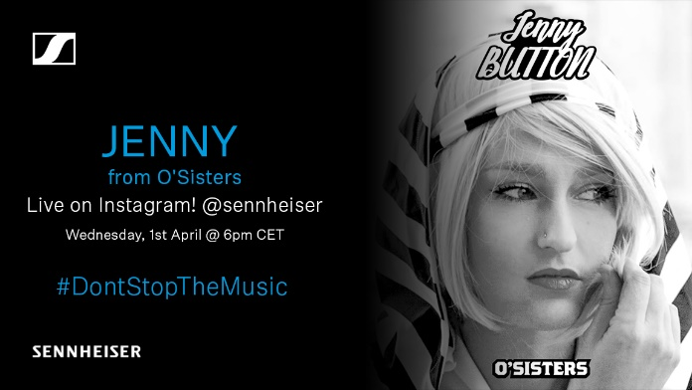 | 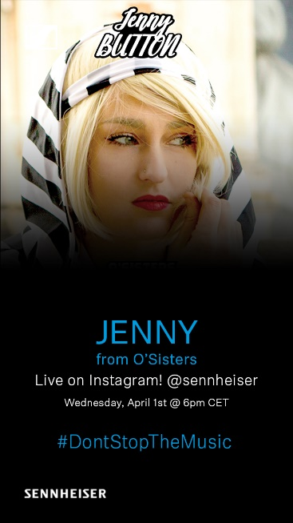
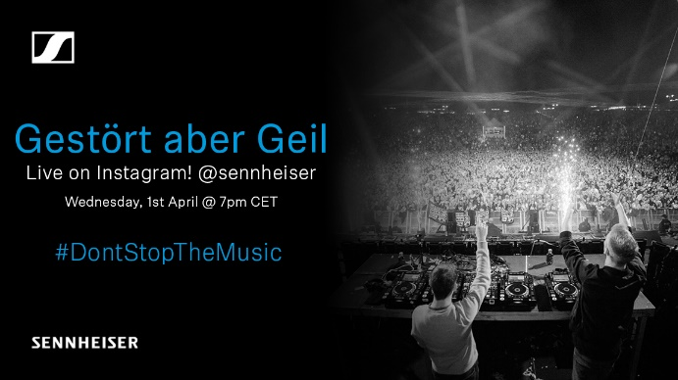 | 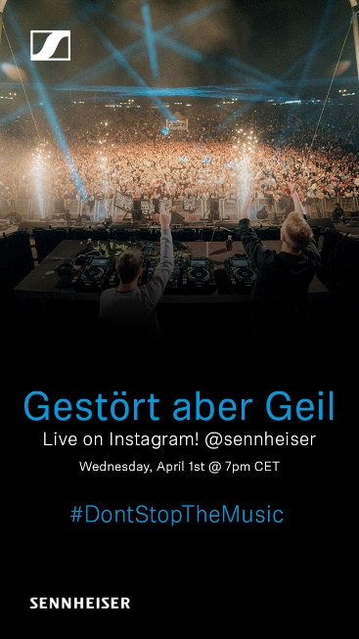
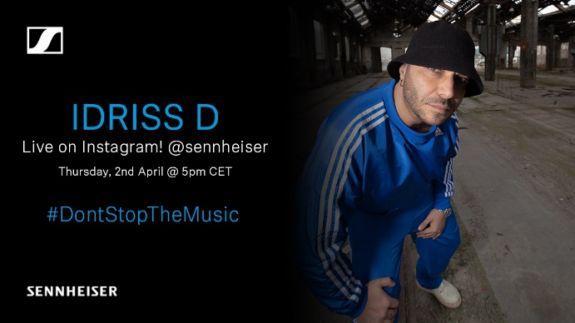 | 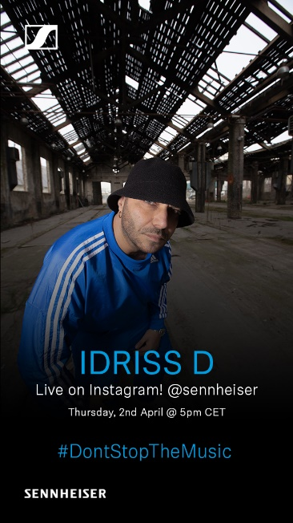
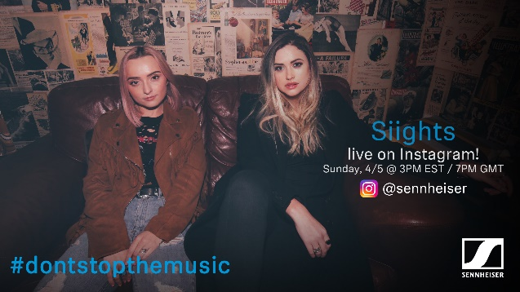 | 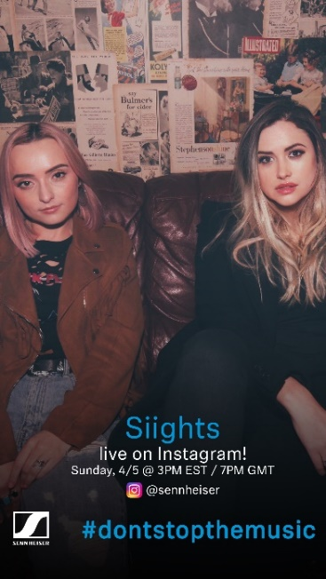

About Sennheiser
Founded in 1945, Sennheiser is celebrating its 75th anniversary this year. Shaping the future of audio and creating unique sound experiences for customers – this aim unites Sennheiser employees and partners worldwide. The independent family company, which is managed in the third generation by Dr. Andreas Sennheiser and Daniel Sennheiser, is today one of the world’s leading manufacturers of headphones, loudspeakers, microphones and wireless transmission systems. In 2018, the Sennheiser Group generated turnover totaling €710.7 million. www.sennheiser.com

Global Press Contacts

Mareike Oer Stephanie Schmidt
mareike.oer@sennheiser.com stephanie.schmidt@sennheiser.com
T +49 0(5130) 600 – 1719 T +49 0(5130) 600 – 1275

Local Press Contacts

Gabby Wallace Sophie Taylor
gabby.wallace@hausmann.com.au sophie.taylor@hausmann.com.au
0431 045 932 0459 117 988

